Project Title
ThermoAQ

Roll No & Name of Students:
Aaryan Sharma 16010123012
Aditey Kshirsagar 16010123017
Aditya Baheti 16010123023

Objective:
To provide real-time, district-level heat wave and air quality alerts across India, empowering users with personalized risk warnings and health advisories through a modern web application.
Work distribution (functionality wise):
Name | Functionality
Aaryan Sharma | Backend API, server setup, MongoDB integration, deployment configuration, authentication, dashboard, report generation, heat wave alert map, routing, and overall project coordination.
Aditey Kshirsagar | Frontend refactoring, authentication UI, protected routes, AQI and weather data handling, HomePage enhancements, health advisory, analytics, and code maintainability.
Aditya Baheti | Figma, Weather app components, location search, data visualization, UI/UX improvements, HomePage and WeatherApp pages, and integration of weather/air quality features.

Database:
- Type: MongoDB (NoSQL)
- Structure: User collection (User.js), stores user credentials and profile info.
- Configuration: Connection via Mongoose in Node.js backend; environment variables managed with dotenv.

Screenshot:
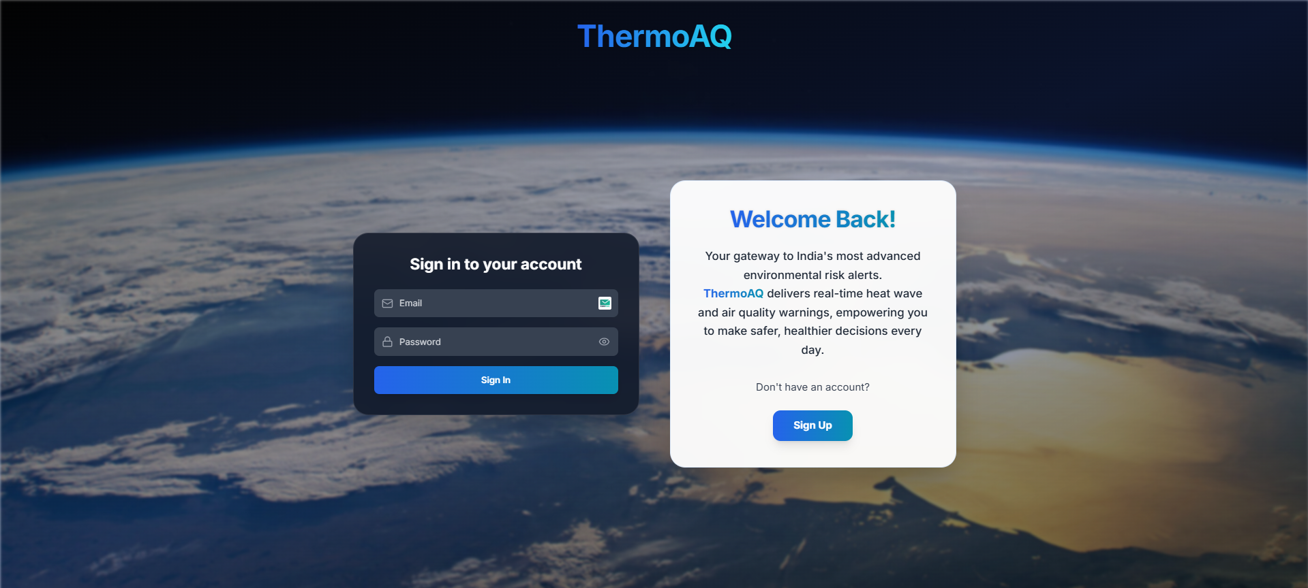
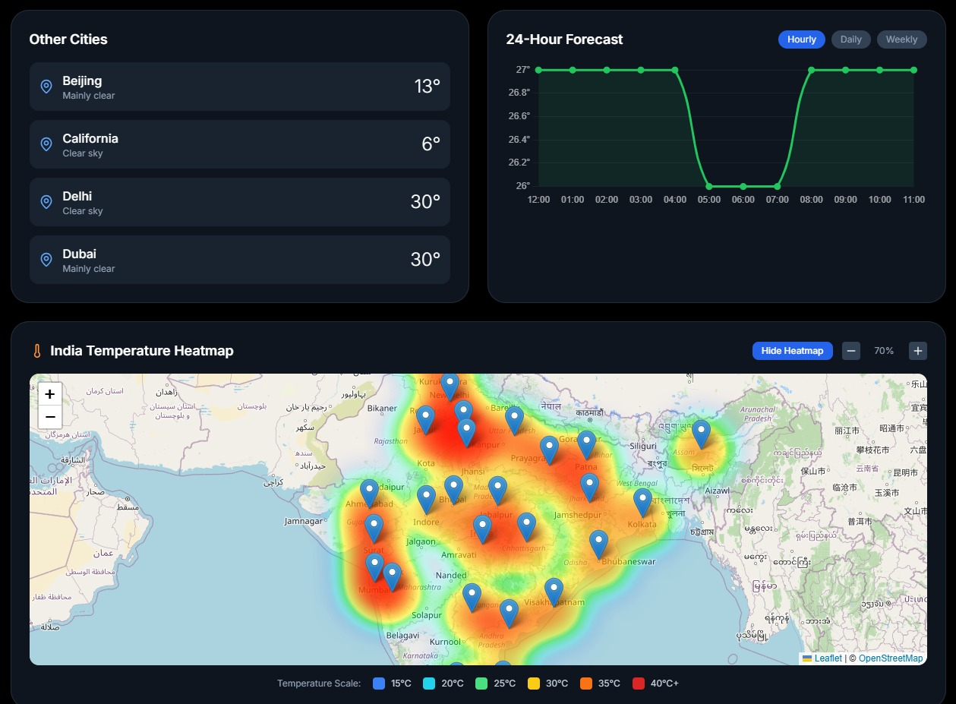

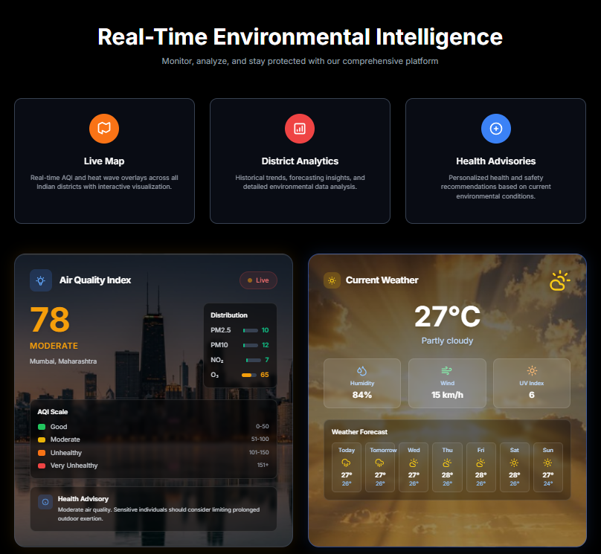
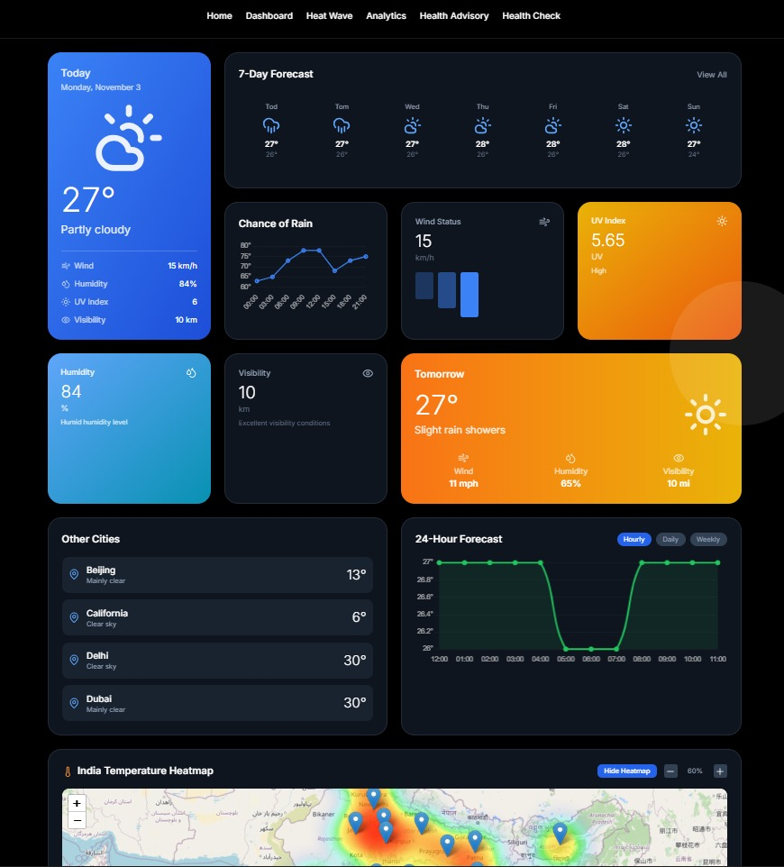

Tech Stack Used:
- FrontEnd: React 19, Vite, Tailwind CSS, Lucide React Icons
- BackEnd: Node.js, Express.js, Gemini
- Database: MongoDB (with Mongoose ODM)

Features implemented:
- User authentication (signup, login, protected routes)
- Real-time weather and air quality widgets
- District-level analytics and health advisories
- Responsive, modern UI with glassmorphism and branding
- Secure API integration and error handling

Technical Issues Encountered and Solved:
- Port Conflict: Node.js server port 3001 was in use; resolved by killing the process and using dotenv for port management.
- UI Consistency: Unified color scheme and branding across authentication and dashboard pages.
- Authentication Security: Implemented protected routes and context-based authentication in React.
- API Integration: Handled asynchronous data fetching and error states for weather/air quality APIs.

The future scope of the project is:
- Mobile app version for wider accessibility
- Push notifications for critical alerts
- Integration with government and local health advisories
- Advanced analytics and historical data visualization
- Multi-language support
GitHub Link:
https://github.com/Aaryan-Sharma-5/ThermoAQ
Deployed Link:
https://thermo-aq.vercel.app/

